How to send emails as another emails address.
Using Office 365 Outlook (Online)
- Access you Outlook email by typing: https://outlook.office.com/mail/ in a new browser window (you might be asked to provide AFC logging credentials).
- Use the mouse to move and locate the cursor on top of the New Mail option, as you normally would to send an email.
- Once the new email window opens, locate the SEND button, you should be able to see 3 consecutive dots to the far right of it, please Left-Click it; a new set of options should be revealed now. Here please choose and Left-Click the Show From option (See picture below).
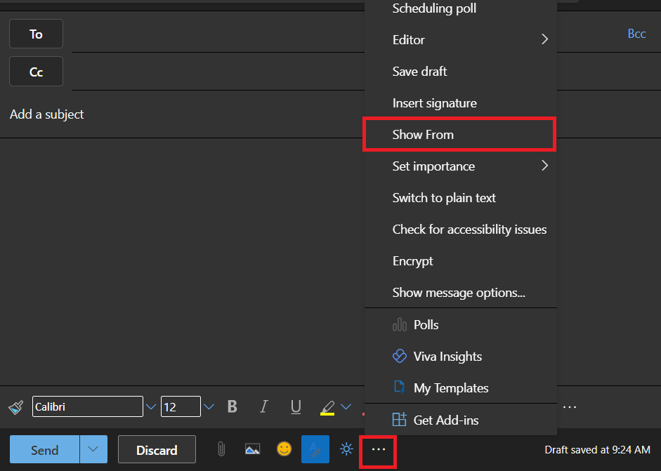
IMPORTANT: Now the From (Sender) option would be shown right on top of the To option, in the email box. please notice that by default, the From email address will always be your own.
- Please Left-Click the From button and Left-Click on Other Email Address...; a new small window will pop-op, here you should be able to type the email address you are trying to use as the sender, please see picture below.
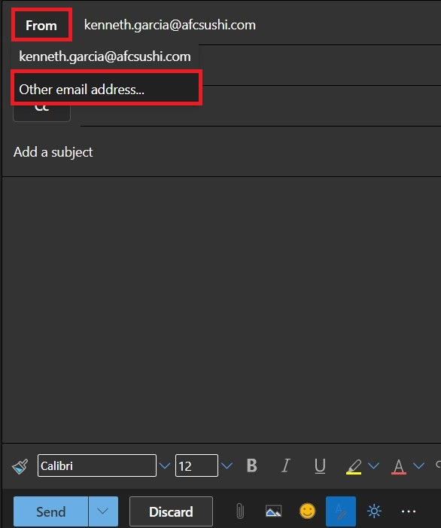
IMPORTANT: This solution(s) should work for both replying to an email(s), and also for creating/sending a new email(s).
5. At this point you may write/send your email, as you normally would.

Using Outlook Windows Local App

- Use the mouse to move and locate the cursor on top of the New Mail option, as you normally would to send an email.
- Once the new email window opens, locate and Left-Click the Options tab, right on top.
- Left-Click on the From icon to display the From Field (see picture below).

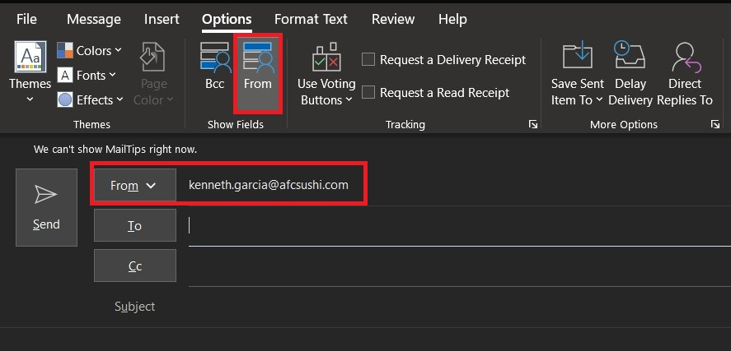

- Left-Click on the DOWN arrow to display the Other Email Address… option; a small pop-out WINDOW will be displayed. Here you may type the email address you want to use as the sender of the email.
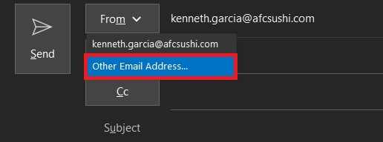

IMPORTANT: This solution(s) should work for both replying to an email(s), and for creating/sending a new email(s).
- At this point you may write/send your email, as you normally would.

