How to Block a specific email address
Using Office 365 Outlook (Online).
- Use mouse to move cursor and position it over the email you want to BLOCK.
- Right-Click on the email.
- Left-Click on Block Sender (follow on screen instructions, if any).

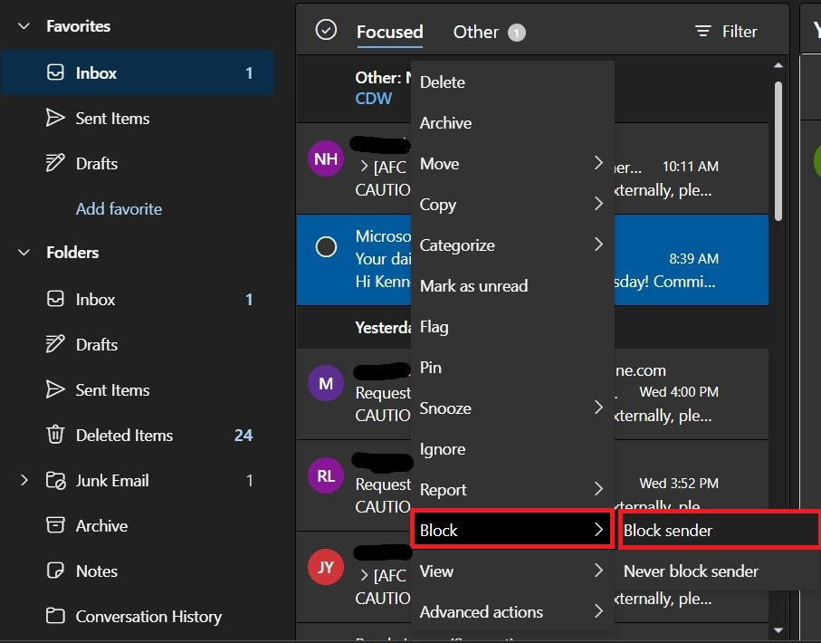

- Delete the suspicious email(s), if Blocking the Sender did NOT already DELETE the email for you, and/or it was NOT already moved to the JUNK folder.

IMPORTANT: Never open any attachments of suspicious emails, instead; always follow the steps listed above.

Using the Outlook Windows Local App.
- Use mouse to move cursor and position it over the email you want to BLOCK.
- Right-Click on the email.
- Hover over JUNK and Left-Click on Block Sender (follow on screen instructions, if any).

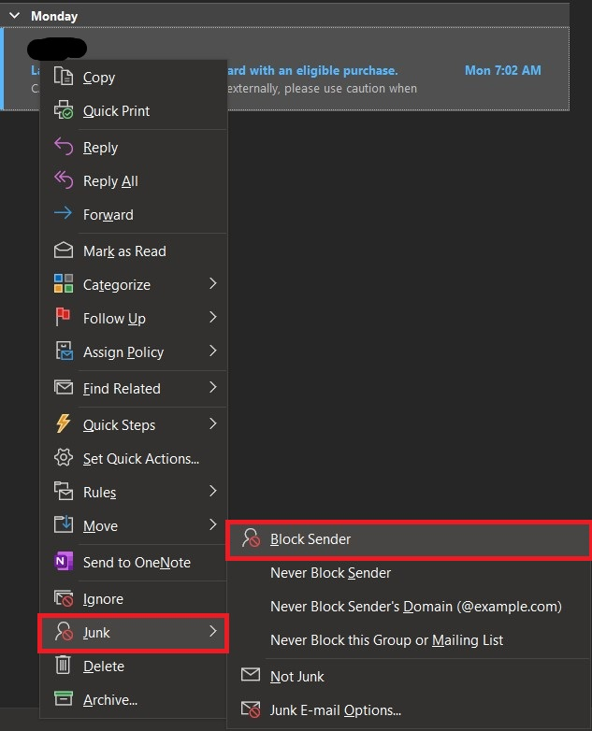

- Delete the suspicious email(s), if Blocking the Sender did NOT already DELETE the email for you, and/or it was NOT already moved to the JUNK folder.
IMPORTANT: Never open any attachments of suspicious emails, instead; always follow the steps listed above.

