Remote Connect to Server Workaround

Why is do I get this ERROR Message?
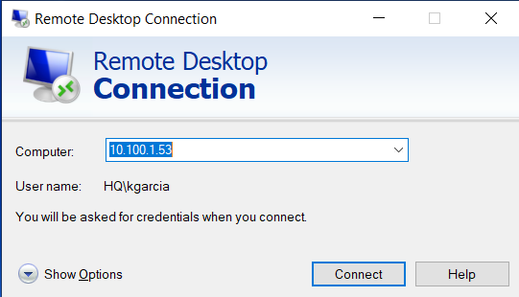
Please follow the instructions below if you are getting this type of error message(s) when attempting to Connect to a Remote Server such as the GP server, for example, using the IPv4 address (10.100.1.53), See pictures below.

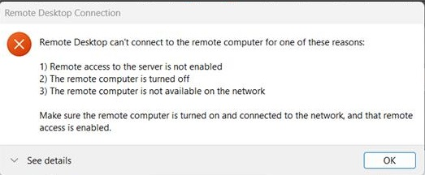

You are getting this error message because you are attempting to Remote connect to the GP Server (10.100.1.53), from a network (your home's internet connection, for example, and/or any other public network for that matter); which does NOT have clearance in our VPN. This explains why you do NOT have this problem while connecting to the GP Server (10.100.1.53), when you attempt the Remote Connection connected to the Office(s) Network and/or Wi-Fi Connection(s).
IMPORTANT: You will always get this ERROR message(s), if you try to connect to this or any Remote Server(s), directly from home or anywhere else, but the AFC office(s).

How can I Resolve this Remote Connection Problem(s)?
FIRST Remote connect to ONE of our computers with public access, which has clearance to access the GP Server, and then connect from that computer(s) to the desired GP server (10.100.1.53).
Please follow the steps below to establish a successful connection to the GP Server.
1. Remote into the following IP Address afc.cumulusnine.com:33389 Left-Clicking Connect (Please see picture below).
IMPORTANT: You will be asked to provide your AFC credentials; you may also check the REMEMBER ME checkbox and click OK to establish the Remote connection.
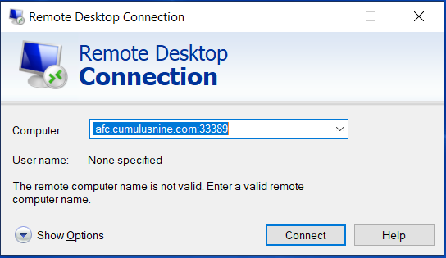
2) Once you are logged-in into this Server, Please Left-Click the Windows Start button (bottom left corner), and Left-Click on the magnifying glass Icon, located on the top RIGHT corner (Next to your Username information), Please see picture below.
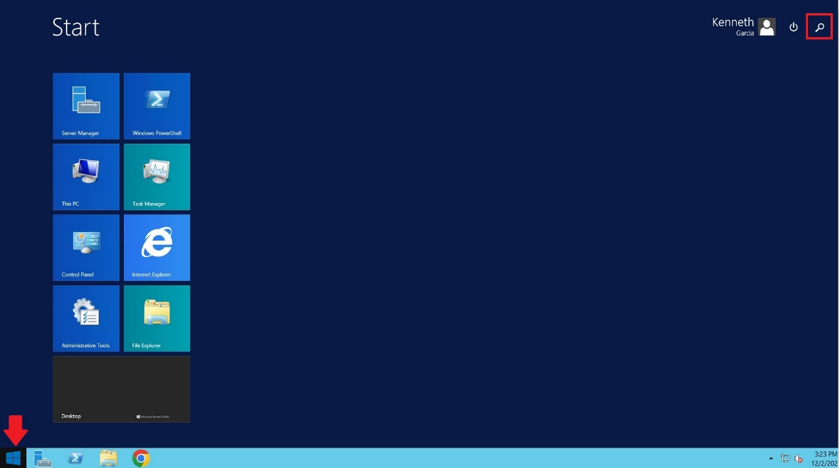

After this, please type “remote” in the search box, to locate the Windows Remote Desktop Connection (RDC) client. See picture below
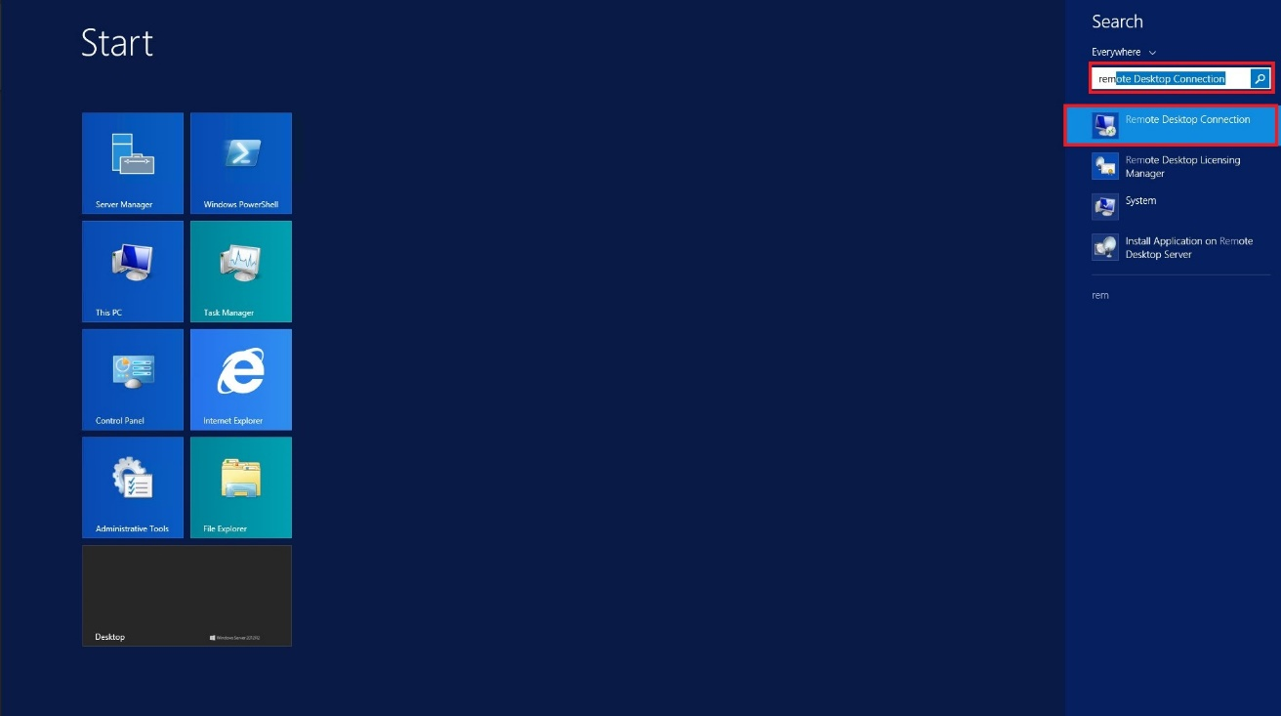

3) Left-Click and/or press ENTER on the Remote Desktop Connection Icon, to open the client user interface. HERE you should be able to log-in as usual, Left-Click on Connect, using the GP Server IP address (10.100.1.53).
IMPORTANT: You will be asked to provide your AFC credentials; you may also check the REMEMBER ME checkbox and click OK to Connect. Please see image below.
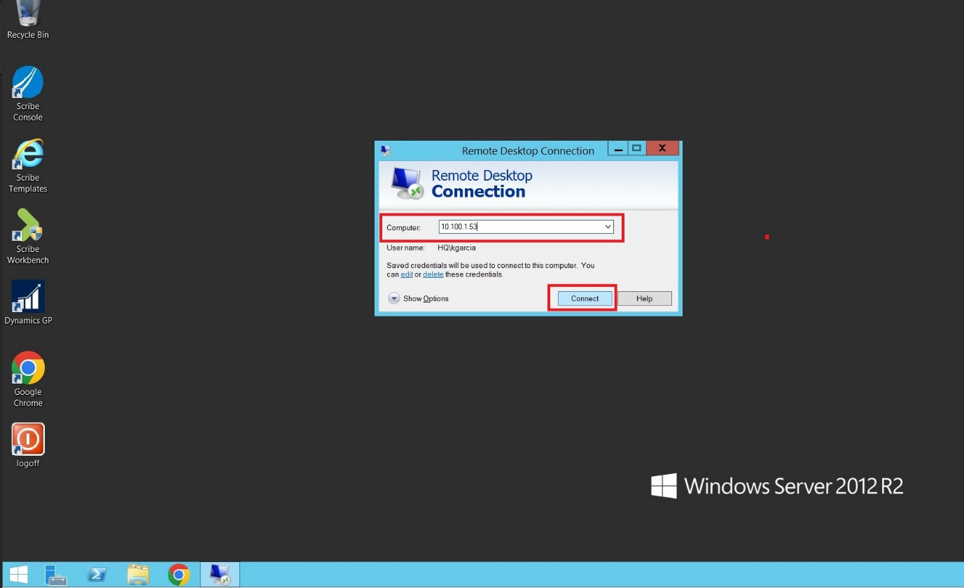

IMPORTANT: Don’t forget to Log-Out once you are done using the Remote Server(s), in this case you will be Required to Log-Out up to 2 times (one for each Remote Connection Session).
Follow the Instructions below To Log-Out and/or terminate your Remote Connection(s).
- Use the mouse and place the cursor on top of the Windows Start button (Lower Left Corner) and Left-Click it.
- Left-Click on your Username (Right upper corner).
- Left-Click on Sign Out (See picture below).
