Please try the following If you are having Network Issues.
1) Locate the Network icon, at bottom right corner, close to the time and date on your taskbar. Left-Click on it to Identify the Wi-Fi network you are currently connected to and/or are having connectivity issues with. See Picture below.
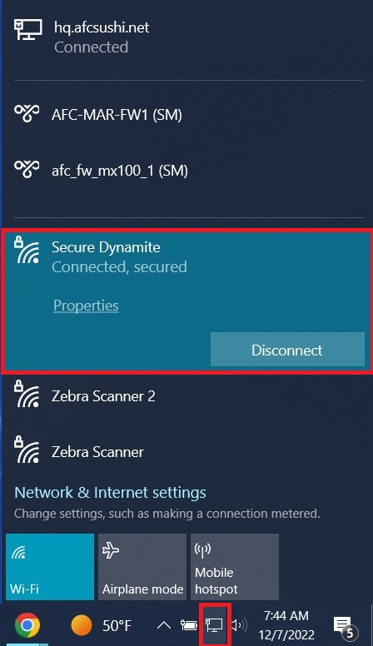

IMPORTANT: Please notice that the Network icon might look like this instead; however, these steps still apply. See Picture below
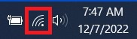

2) After Identifying the Network, you are currently, Left-Click on the Network & Internet Settings option(s). See picture below
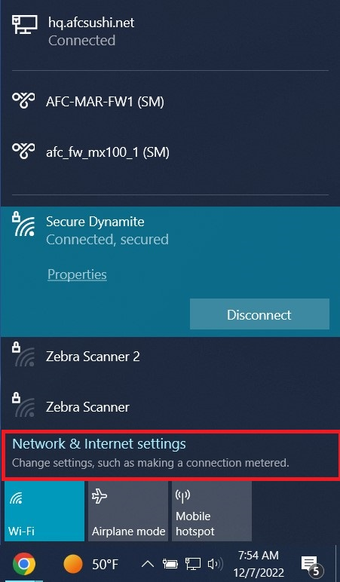

3) If you are having Wi-Fi connectivity issues, the Network Status will reflect this; Left- Click on Wi-Fi. See Picture below
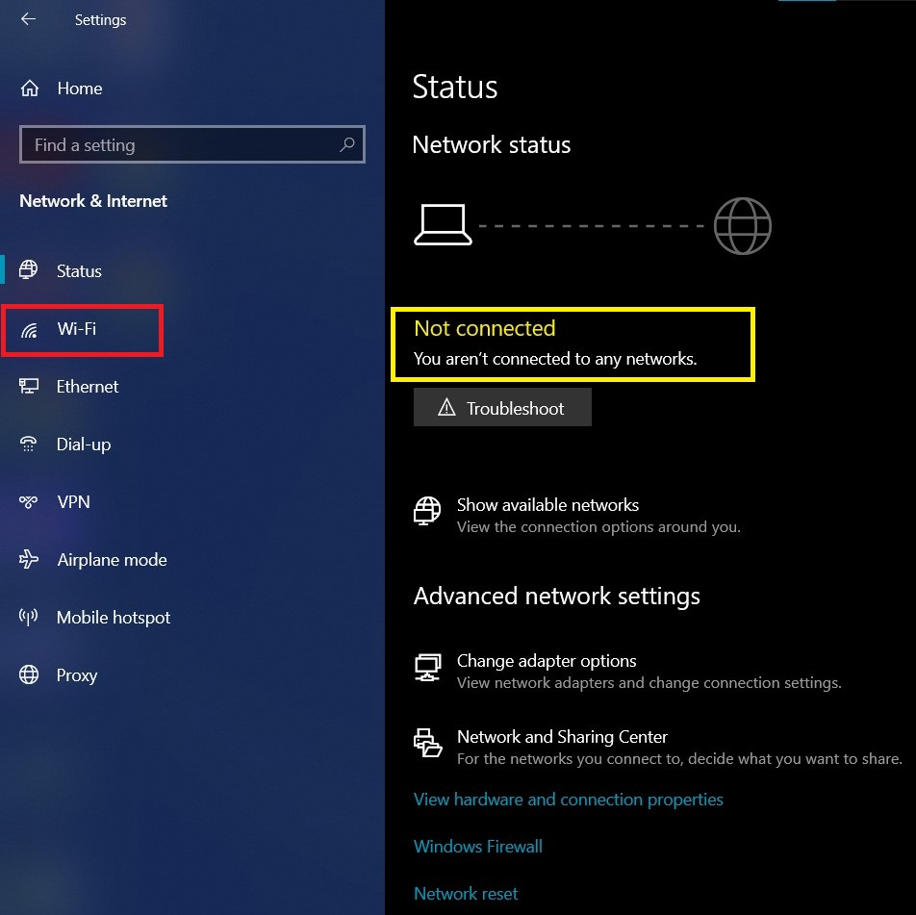

4) Make sure the Wi-Fi switch is turned on if your computer has one; Left-Click on Manage known networks.
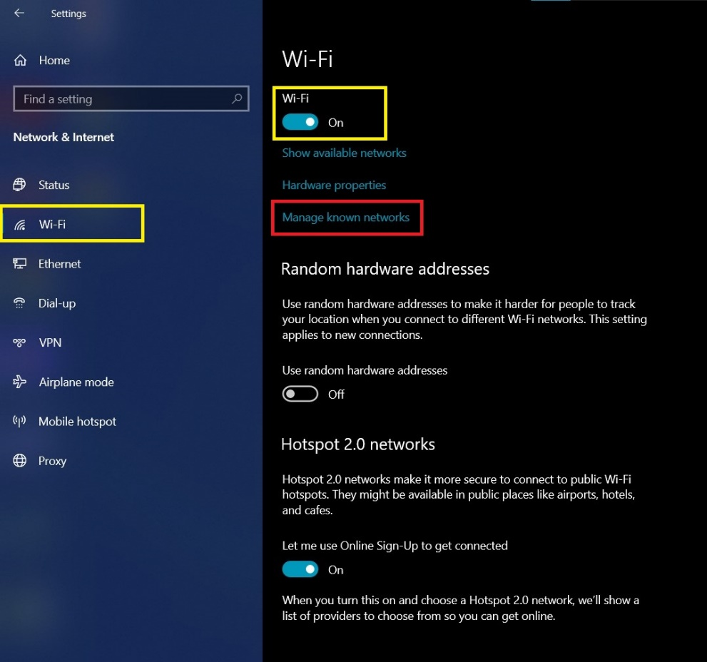

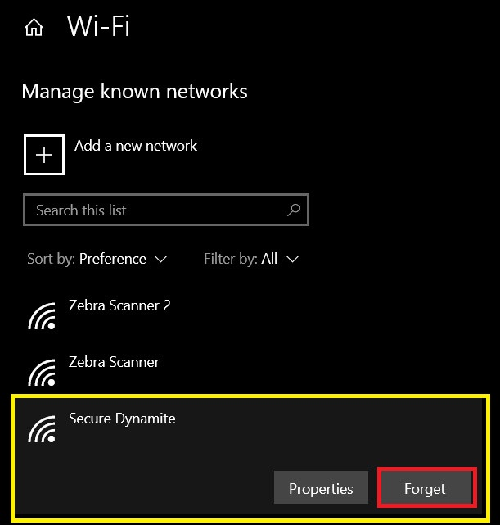
5) Locate the Network/Wi-Fi connection you are having connectivity issues with, Left-Click on it to unlock the Properties and Forget options. Left-Click on Forget. See Picture below

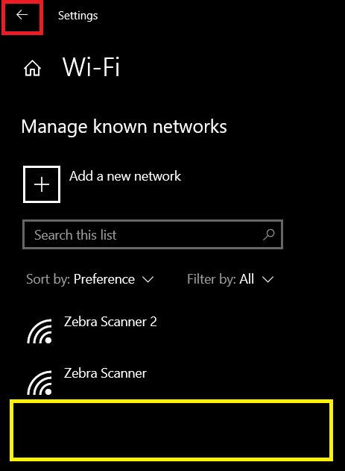
6) Notice the Network/Wi-Fi connection in question, disappears. Left-Click on the Back arrow. See Picture below

7) Left-Click on Show available networks.
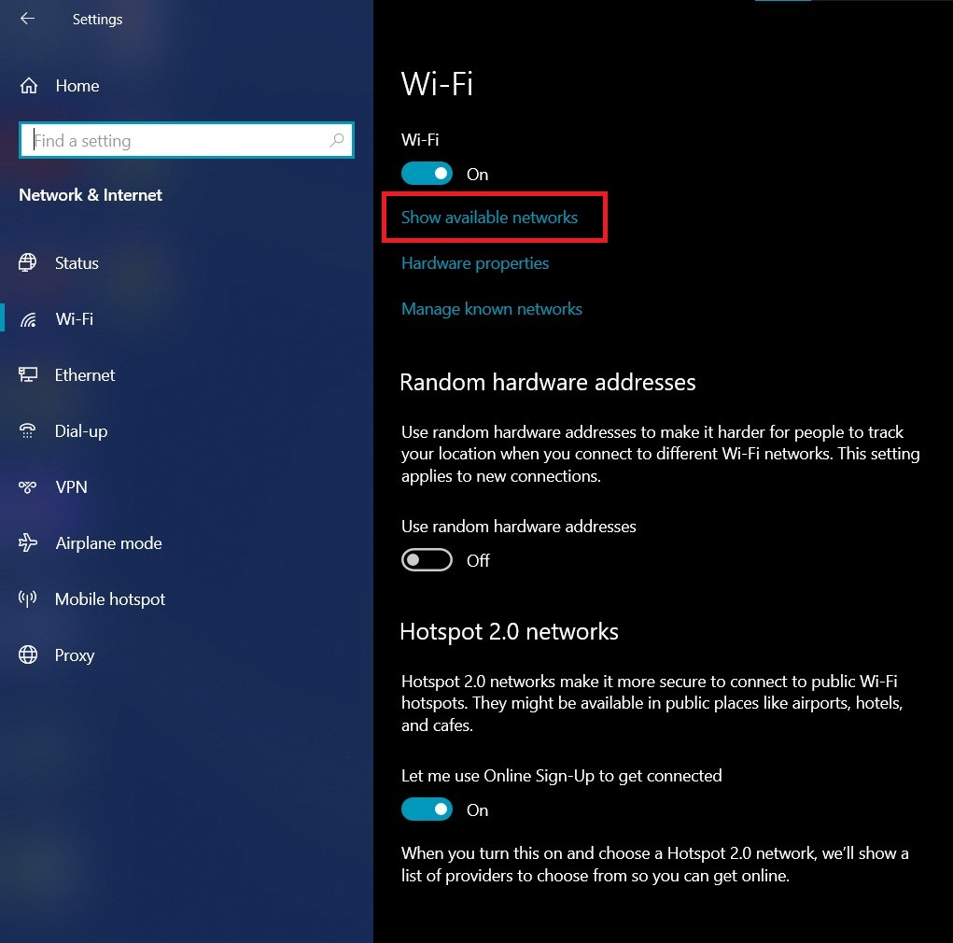

8) Notice a small Pop-up window will appear on screen, showing you all the available Wi-Fi networks and/or Wi-Fi networks within range. Scroll down, if needed, until you find the Wi-Fi network, you wish to connect to. Left-Click on Connect (You will be required to enter the Wi-Fi network Password, contact IT Tech Support and/or Management if you do NOT know this information).
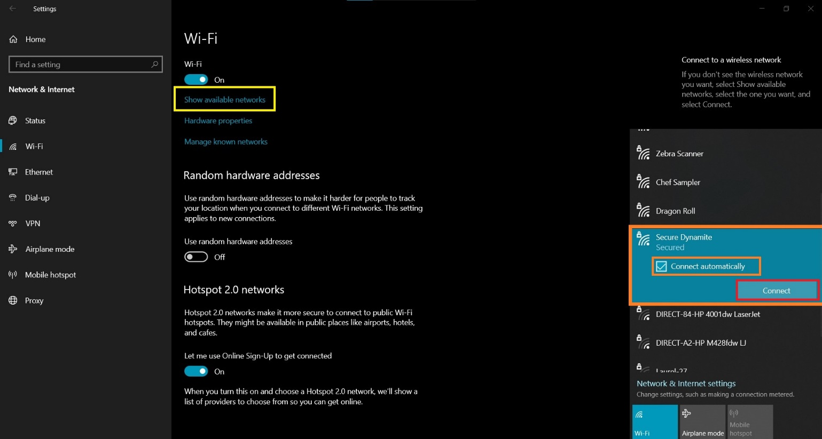

IMPORTANT: Make sure the Connect automatically checkbox is CHECKED. See Picture below
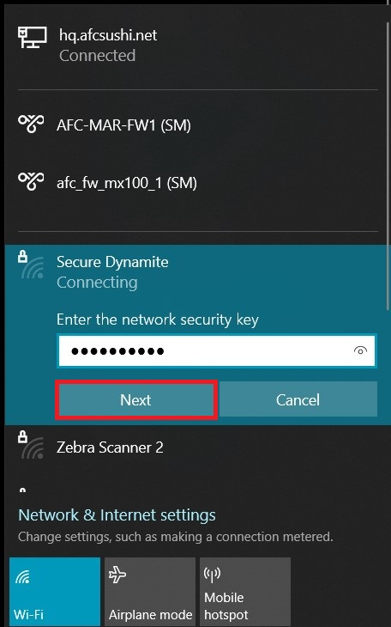

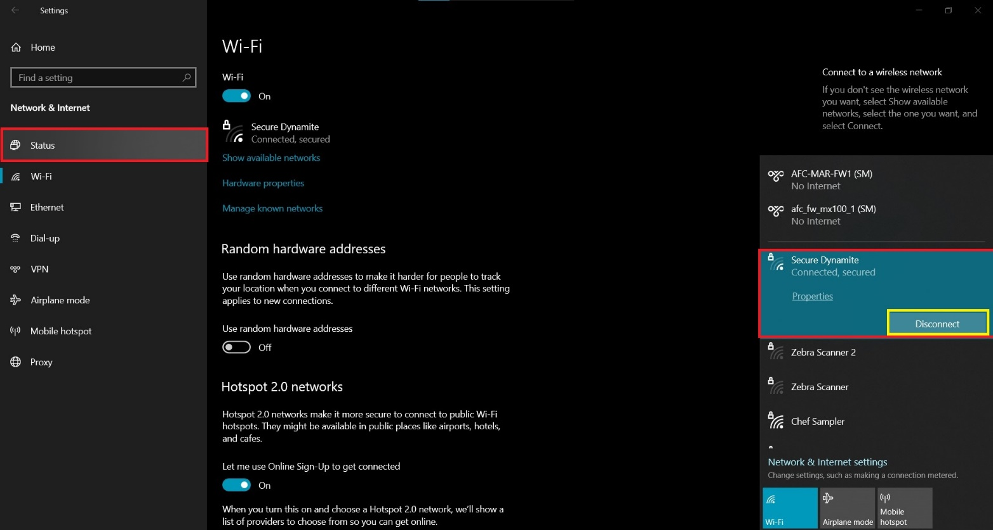
9) Notice the Wi-Fi network options have changed; Left-Click on Status.

10) If everything was done correctly, you should be able to see the current network connection status reflects and/or shows that your computer is connected to the desired Wi-Fi network(s). After this, you may simply close this window(s) and continue with your task(s).
