How to BLOCK Phone Numbers on ZOOM

Using ZOOM Web Application (Online)
1) Go to https://zoom.us/signin#/login and provide your logging Credentials AFC email address and Password. Please use the default AFC password, if you do NOT recall changing it.
IMPORTANT: The default AFC password is afcAFC(EmployeeID).
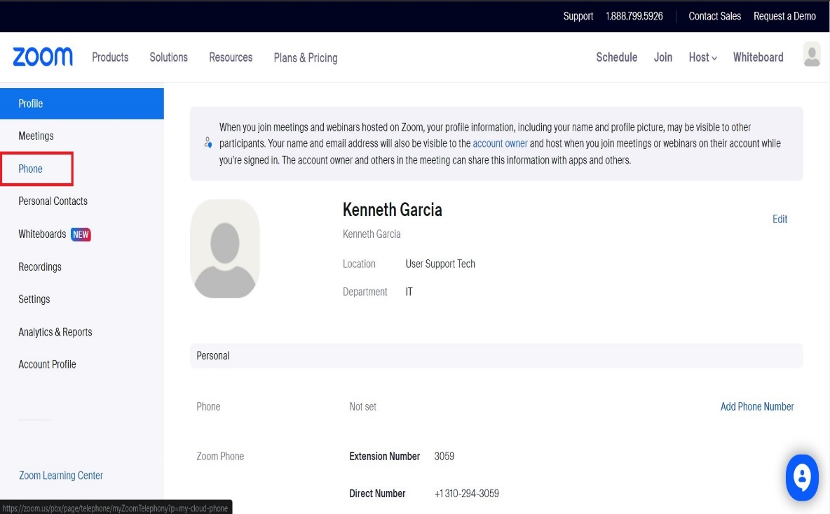
2) Left-Click the Phone option.

3) Left-Click History.
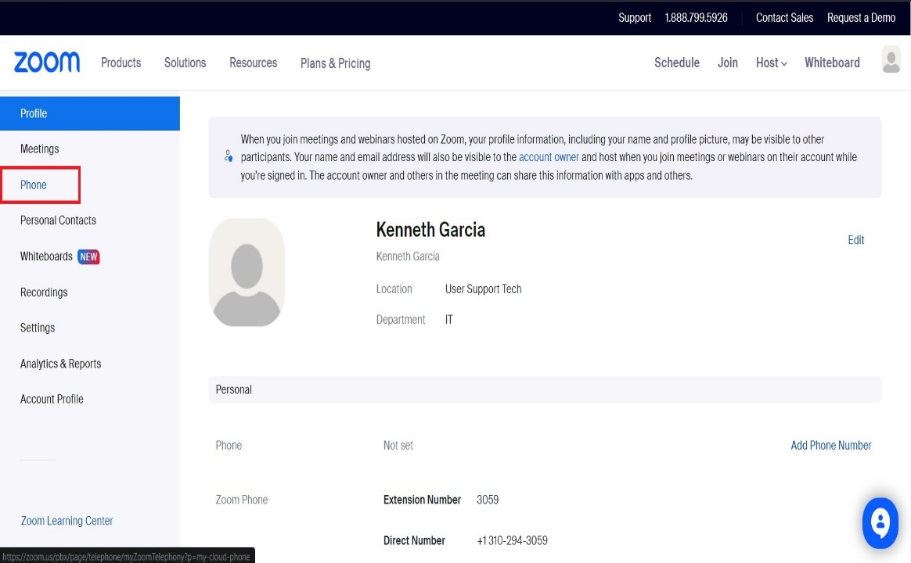

4) Look for the Phone number and/or Caller ID you wish to BLOCK. You may scroll down, user the Date filters at the top, and you may even search it using the search box. Left-Click on the Checkbox next to the Phone number(s) in question and Left-Click BLOCK. See picture Below.
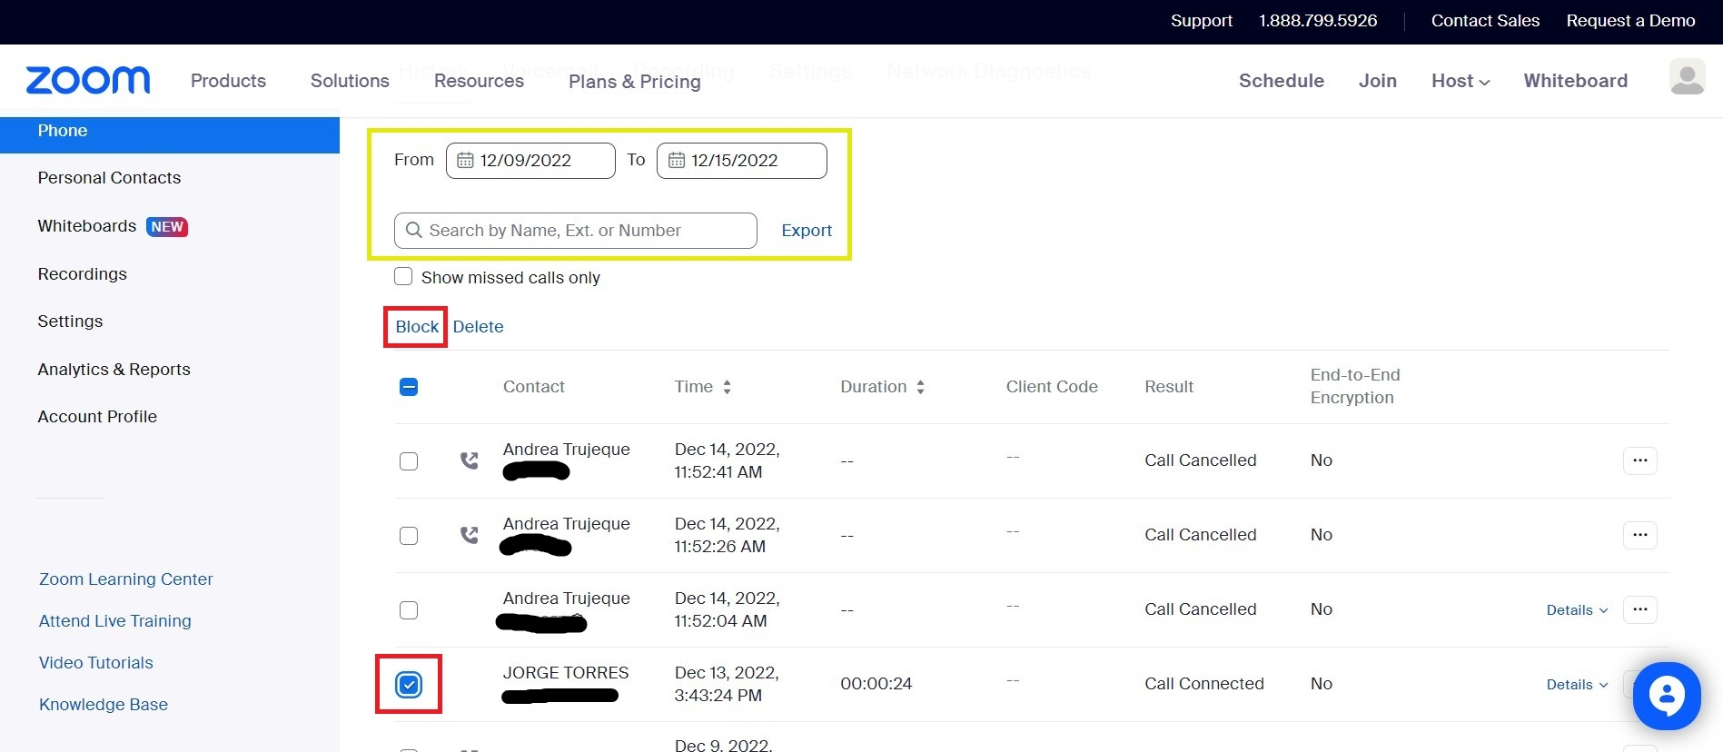

IMPORTANT: You will get a Pop-up message, Please follow the on-screen instructions. Give a reason for BLOCKING the Caller ID and Left-Click BLOCK. See Picture below.
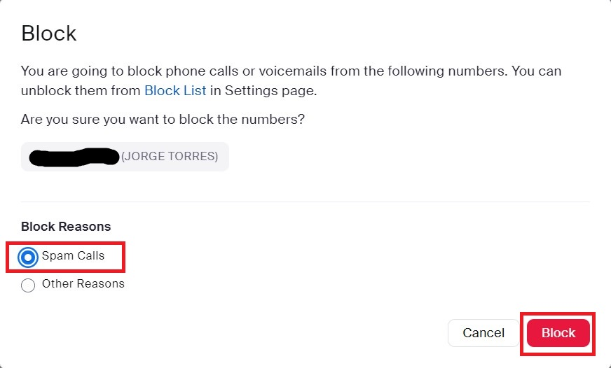

Using ZOOM Desktop Application (Windows 10 & 11).
1) Type ZOOM in the search box, located at the lower Left corner, next to the Windows Start button; Left-Click Open.
Provide your logging Credentials AFC email address and Password. Please use the default AFC password, if you do NOT recall changing it.
IMPORTANT: The default AFC password is afcAFC(EmployeeID).
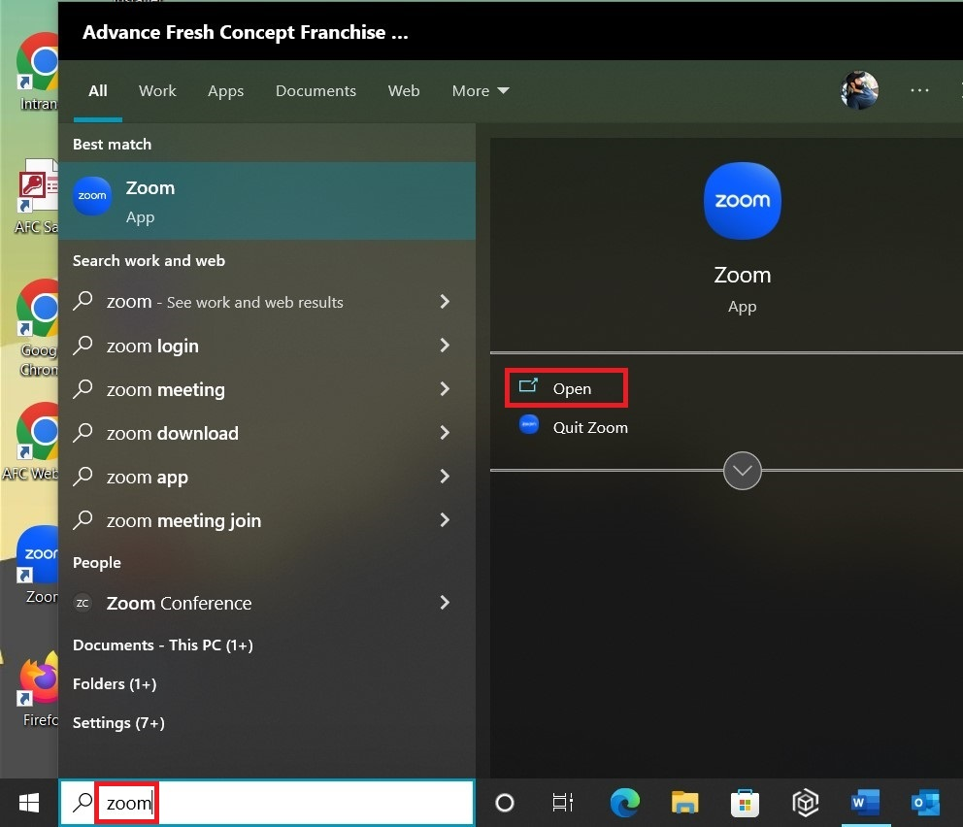

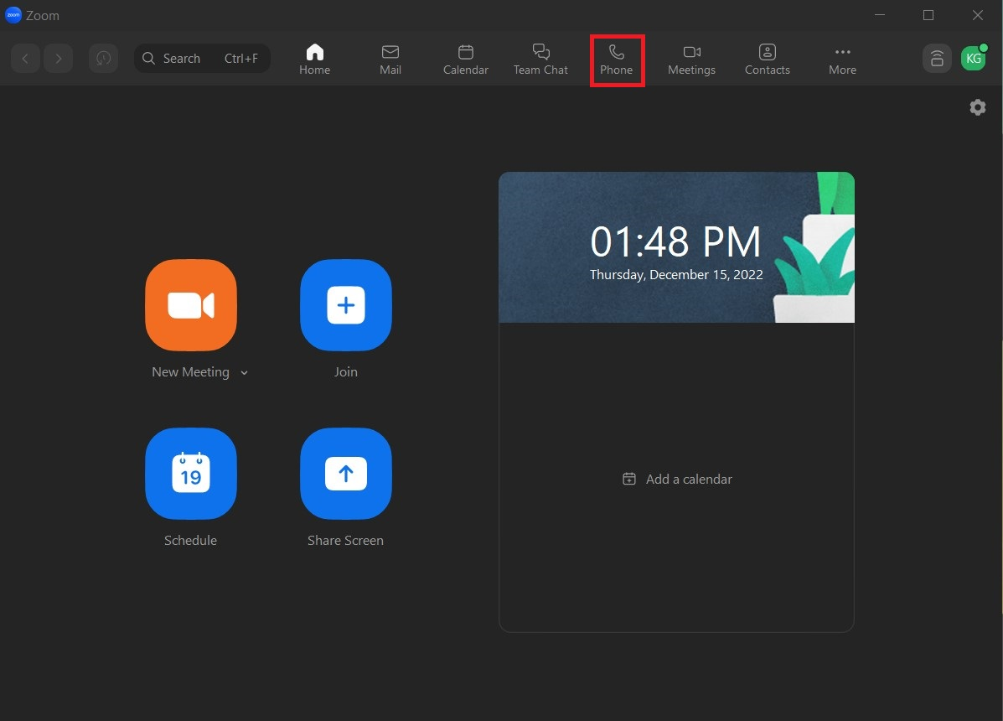
2) Left-Click on the Phone Icon.

3) Make sure the History sub–Tab Option is selected. Look for the phone number and/or Caller ID you wish to BLOCK. You may scroll down to find it. Left-Click the 3 dots button next to the phone(s) in question.
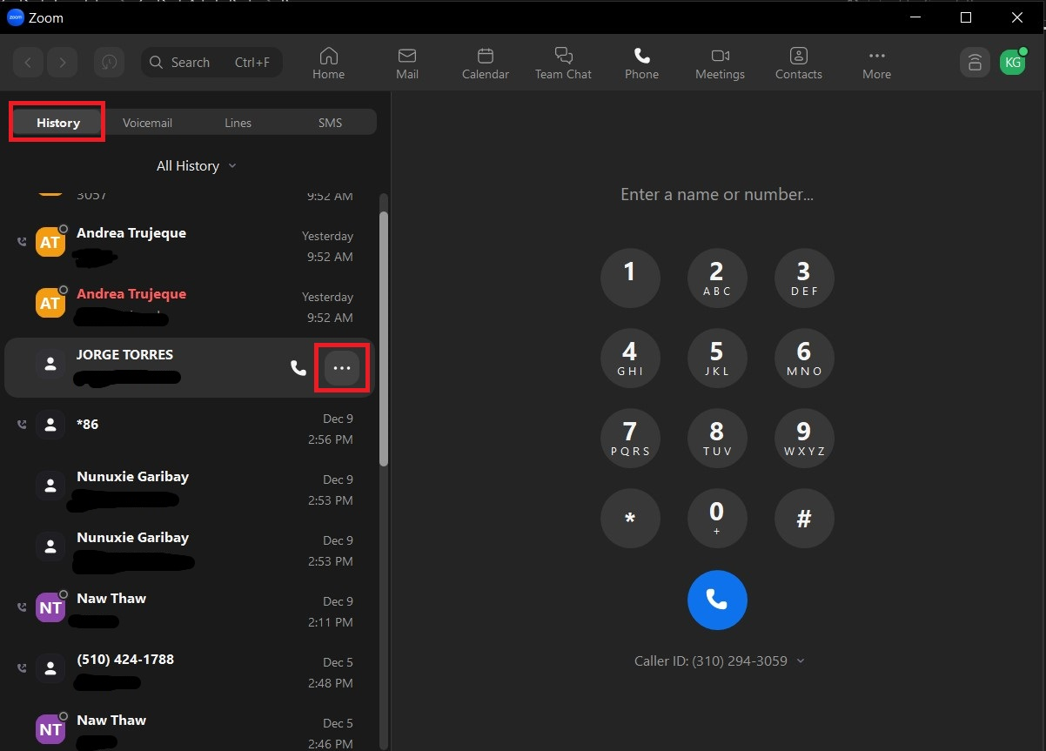

4) Use the mouse and hover over the BLOCK NUMBER option, Left-Click Other Options.
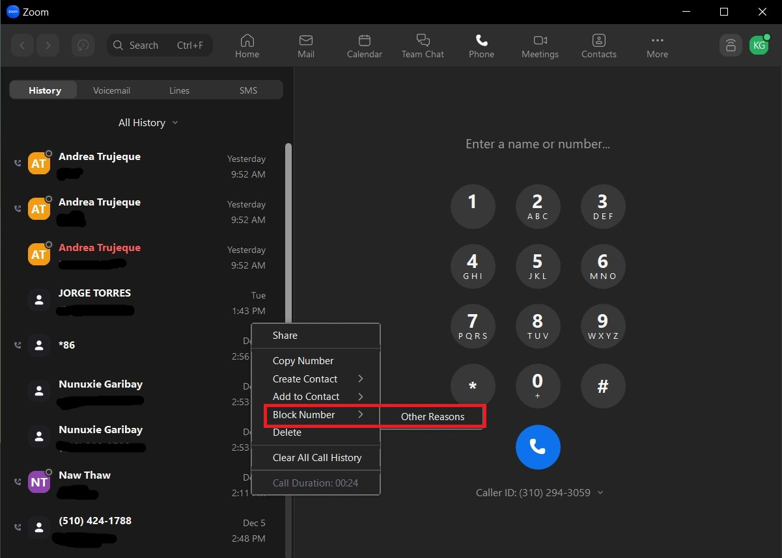

5) Left-Click BLOCK, to confirm this action.
