Please try the following If you are having Network Issues.
1) Locate the Network icon, at bottom right corner, close to the time and date on your taskbar. Left-Click on it; then Left-Click on the LEFT ARROW, next to the Wi-Fi Icon, and Identify the Wi-Fi network you are currently connected to and/or are having connectivity issues with. See Picture below.
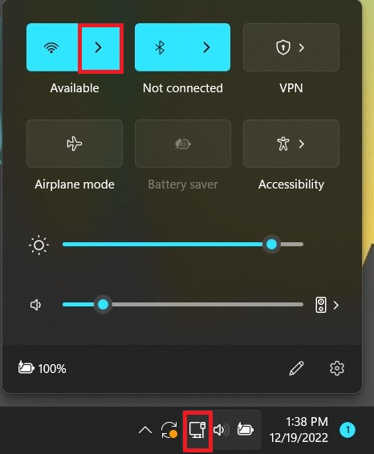
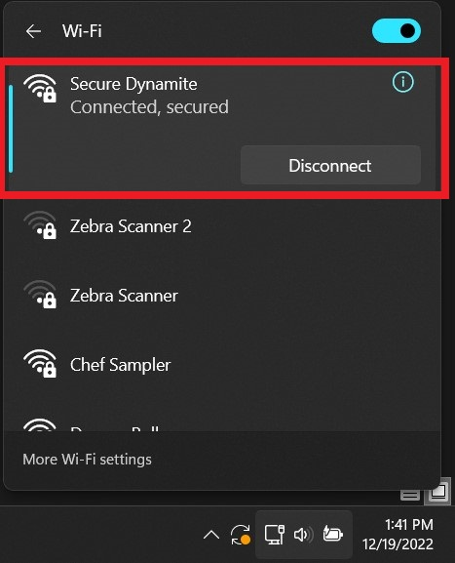

IMPORTANT: Please notice that the Network icon might look like this instead; however, these steps still apply. See Picture below

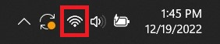

2) After Identifying the Network, you are currently having problems with; Left-Click on the More Wi-Fi Settings option(s). See picture below
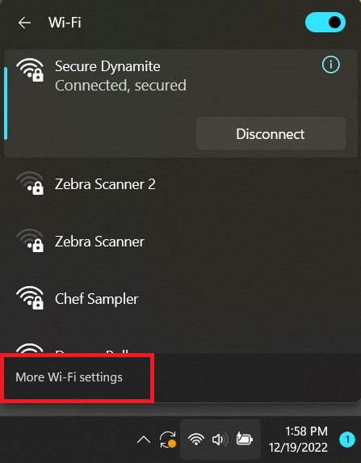

3) If you are currently connected to a Wi-Fi network, the Network Status will reflect this. See Picture below
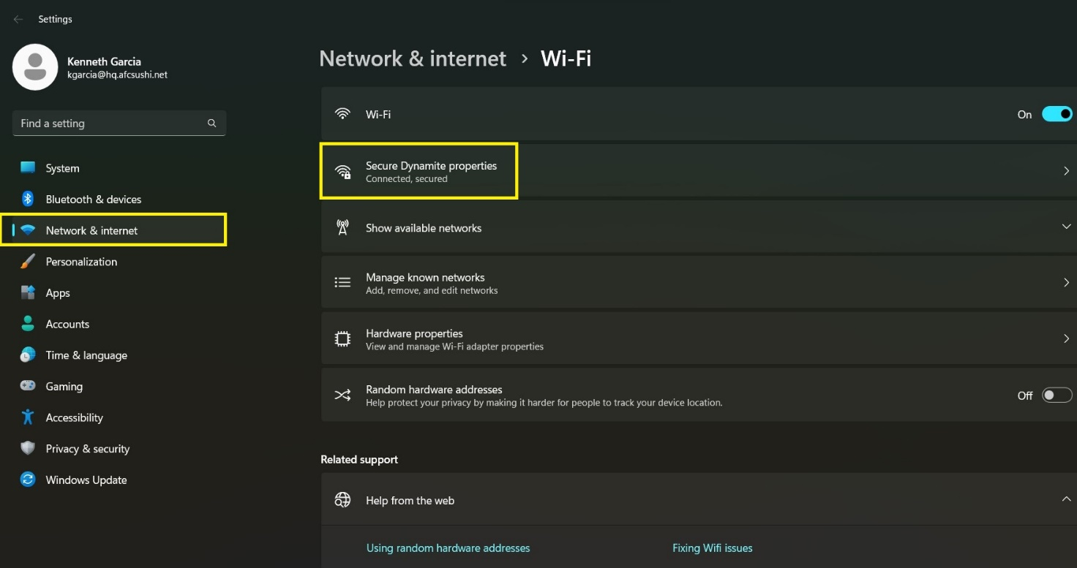

4) Make sure the Wi-Fi switch is turned on if your computer has one; Left-Click on Manage known networks.
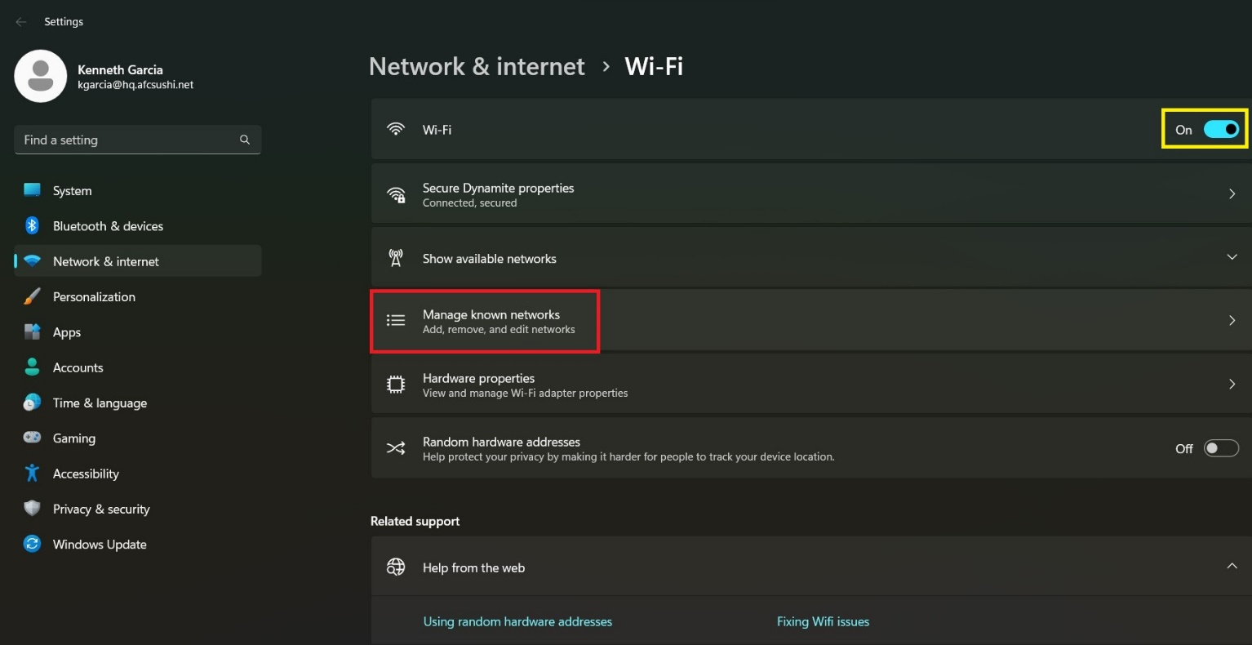

5) Locate the Network/Wi-Fi connection you are having connectivity issues with, Left-Click on Forget. See Picture below
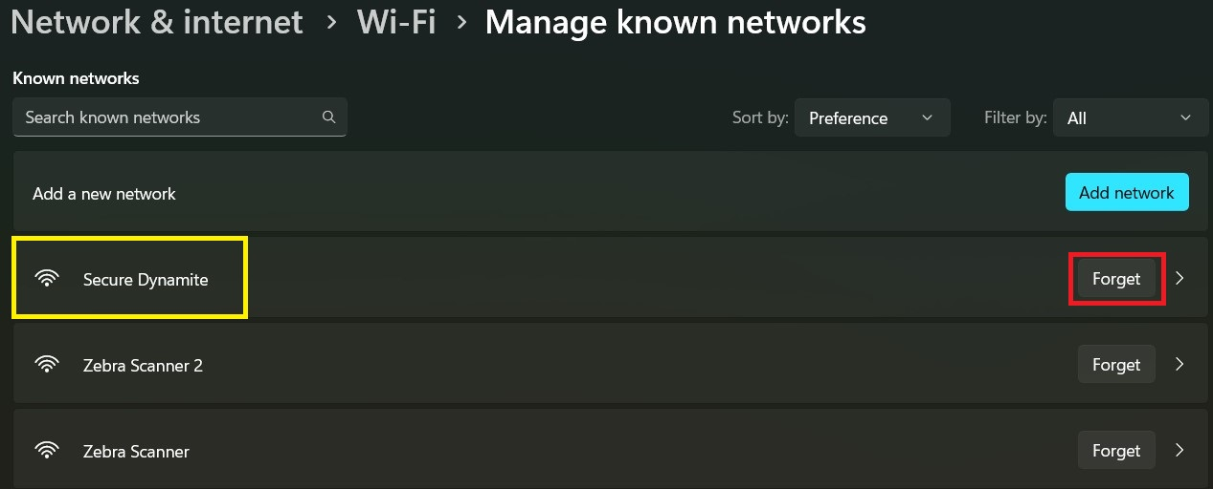

IMPORTANT: Notice the Network/Wi-Fi connection in question, disappears. Left-Click on the Back arrow. See Picture below
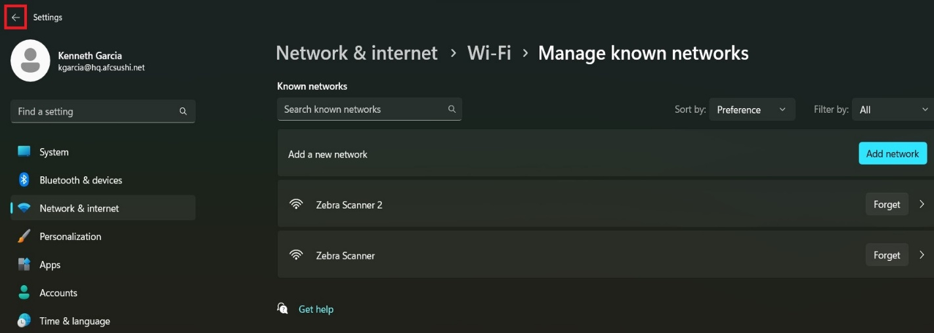

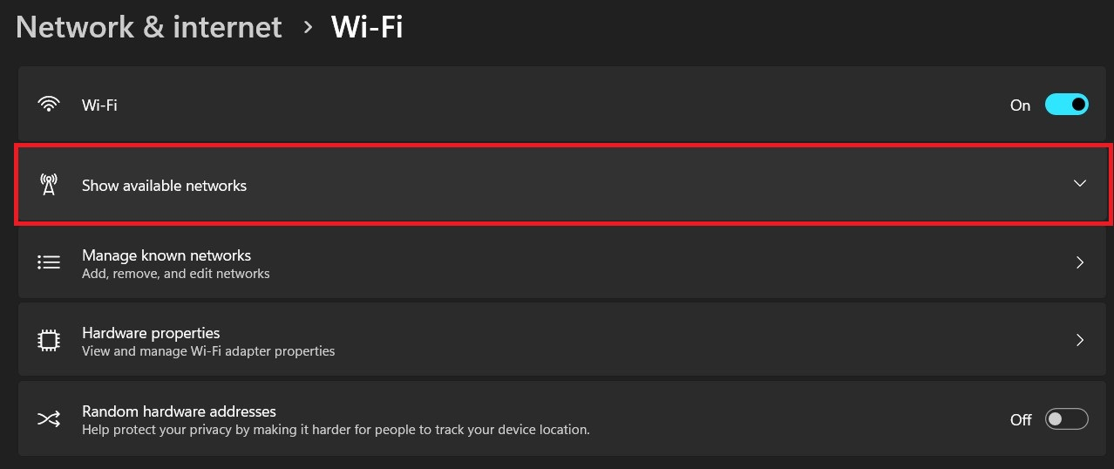
7) Left-Click on Show available networks.

8) Notice the tab will drop down, showing you all the available Wi-Fi networks and/or Wi-Fi networks within range. Scroll down, if needed, until you find the Wi-Fi network, you wish to connect to. Left-Click on Connect (You will be required to enter the Wi-Fi network Password, contact IT Tech Support and/or Management if you do NOT know this information).

IMPORTANT: Please make sure the Connect automatically BOX is checked.
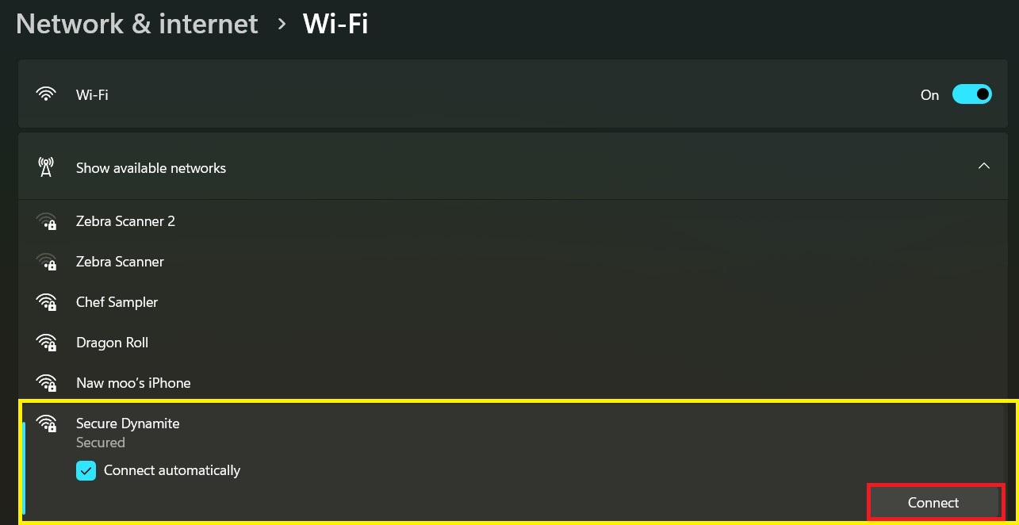

9) Enter/Provide the Network password and Left-Click NEXT.
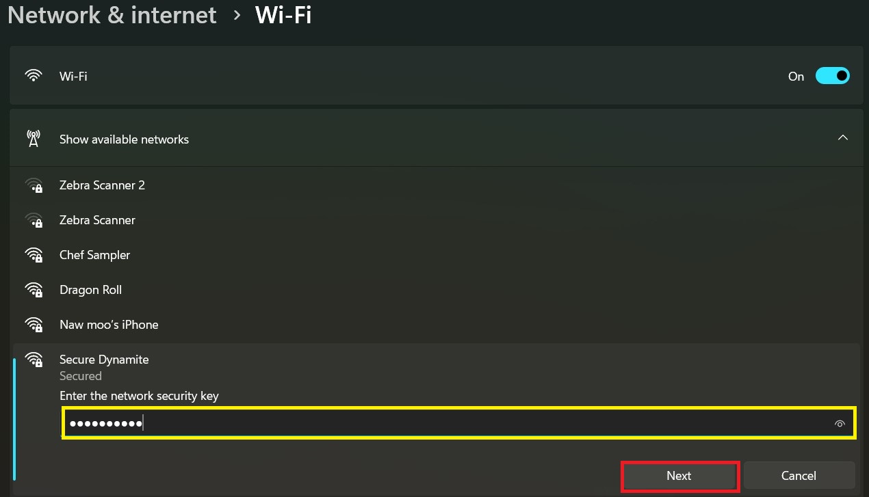

10) If everything was done correctly, you should be able to see the current network connection status reflects and/or shows that your computer is connected to the desired Wi-Fi network(s). After this, you may simply close this window(s) and continue with your task(s).
IMPORTANT: Notice the network, if properly connected, will NOW show the Disconnect option, instead of Connect.
