If you're noticing you're not receiving new emails even though your connected to MS server, do the following to correct the issue:

Windows 11
1) Close Outlook
2) Right-Click on the Windows Start button, located in the lower-center part of your screen. See picture below.
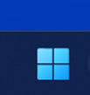

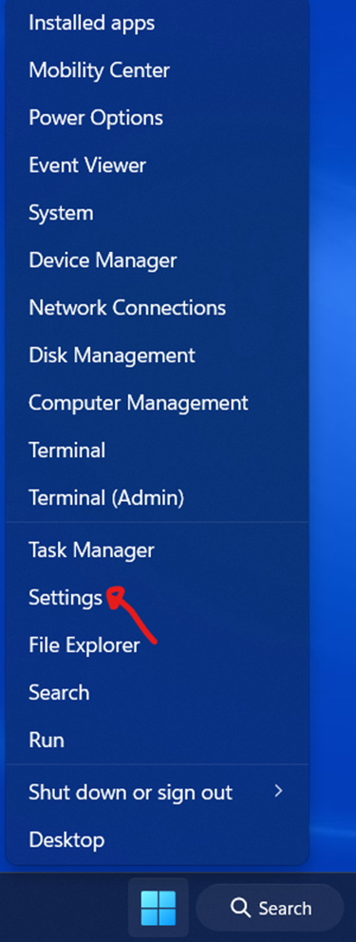
3) Left-Click on Settings.

4) Left-Click on Accounts.
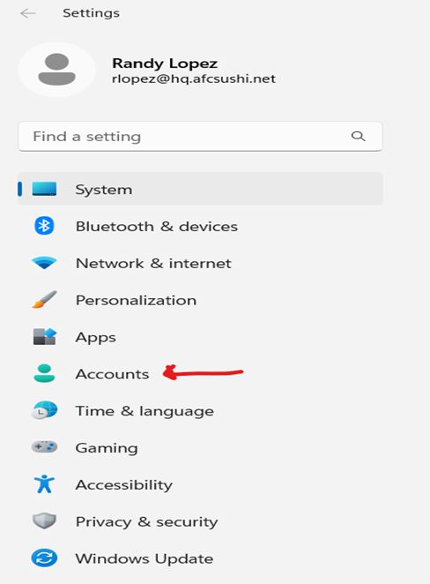

5) Left-Click on Access work or school.
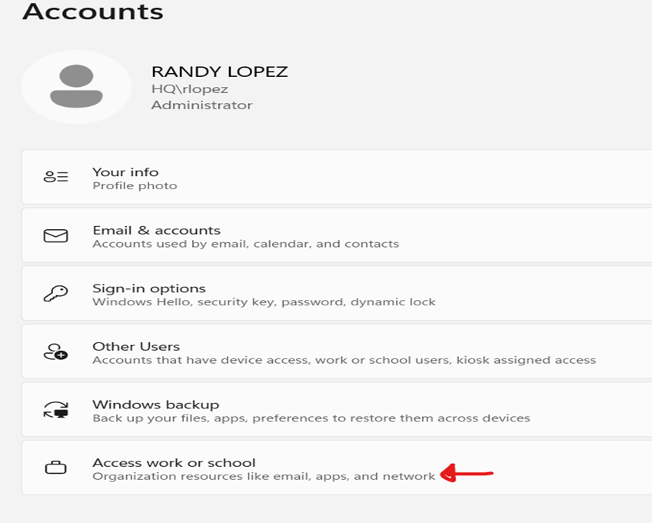

6) Locate your AFC email address and Left-Click on Disconnect.
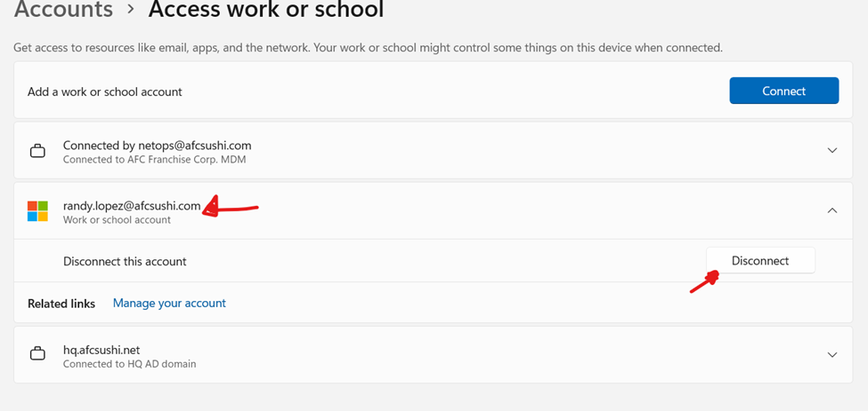

7) Exit this window.
8) Open/relaunch Outlook.
IMPORTANT: Now Outlook will REQUEST your AFC Credentials (email & password). If you don't remember changing your password, the default password is: afcAFC (employee number).

Windows 10
1) Close Outlook
2) Right-Click on the Windows Start button, located in the lower-left corner of your screen. See picture below.
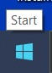

3) Left-Click on Settings.
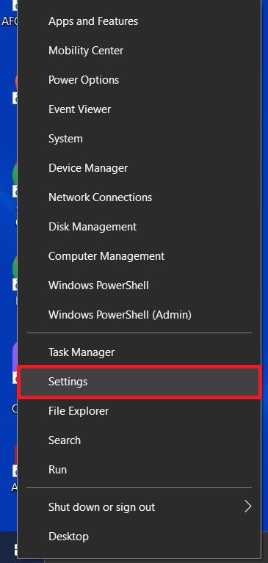

4) Left-Click on Accounts.
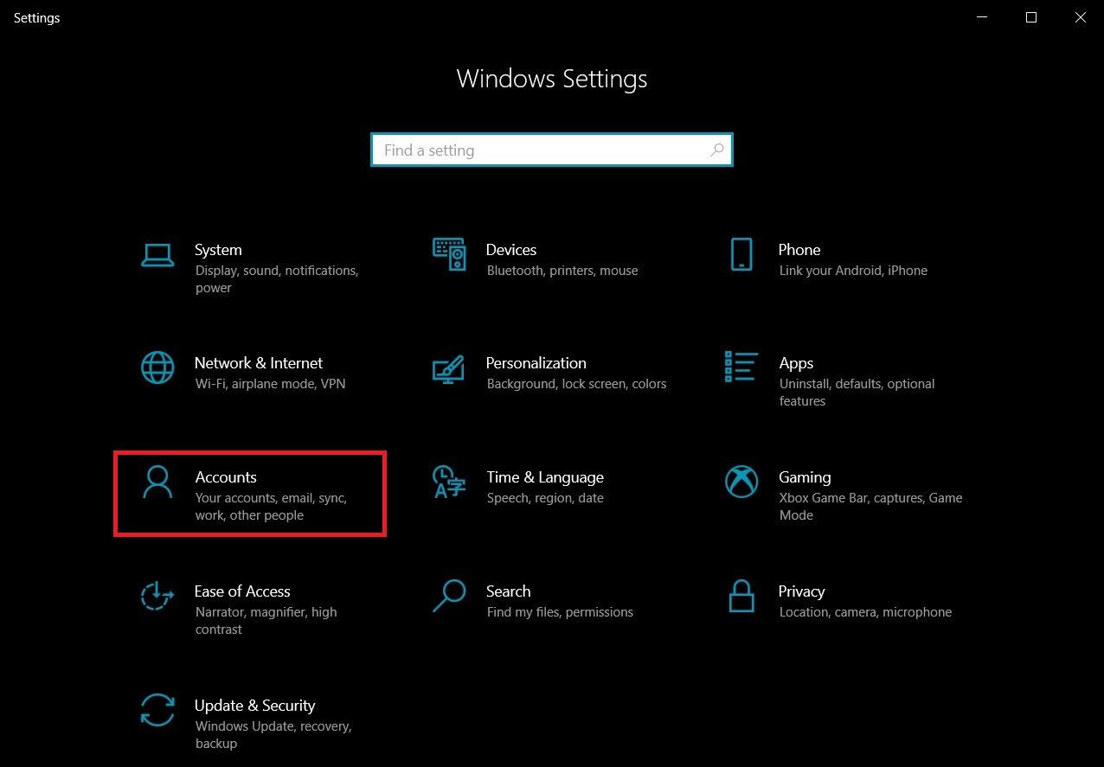

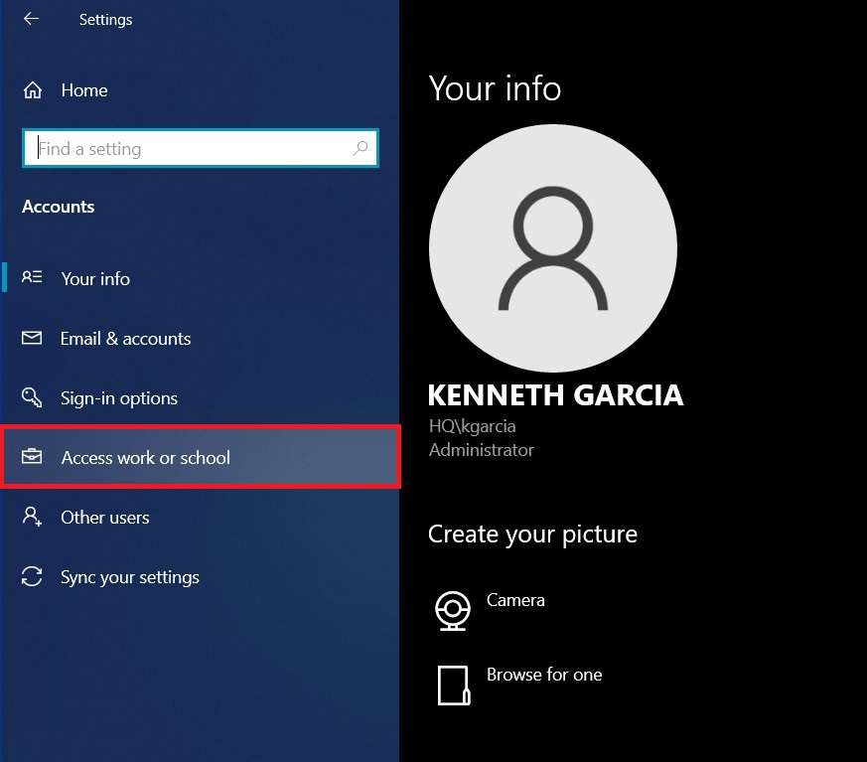
5) Left-Click on Access work or school.

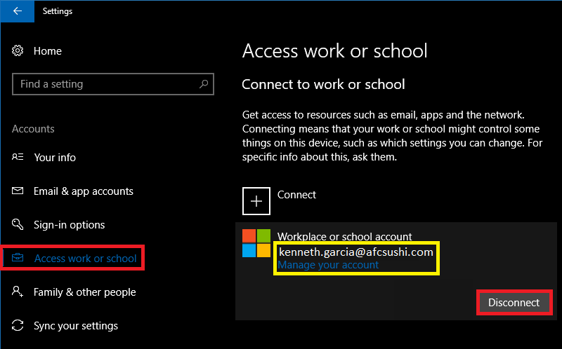
6) Locate your AFC email address and Left-Click on it to unluck the Info and Disconnect options; Left-Click on Disconnect.

7) Exit this window.
8) Open/relaunch Outlook.
IMPORTANT: Now Outlook will REQUEST your AFC Credentials (email & password). If you don't remember changing your password, the default password is: afcAFC (employee number).

